STEMS NEWS
Supporting Teachers and Staff in Motivating Adult Learners - Newsletter

FIND US ON FACEBOOK:

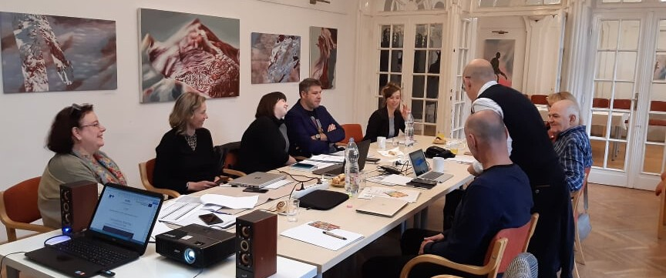
The first transnational project meeting took place in Pécs/Hungary by the lead applicant between 28-29. October, 2019.

THE CONTEXT

In order to improve the current insufficient participation of adults in learning in partner countries and across Europe, we need to provide high-quality education opportunities and identify main barriers that hinder participation and persistence of adults in learning. The aim of the project is to address problems and difficulties and respond to the needs of adult education providers and adult learners. The project aim is to contribute to: - increasing adult participation in learning - adult learners' demands for quality education provision that offers necessary support and takes into account learner needs - adult education providers' needs for teachers and staff equipped with necessary competences, strategies, and tools for motivating and engaging adult learners as well as maintaining their persistence in learning. The project plans to increase the target groups' quality of interaction with adult learners due to increased communication, and motivation competences, better cooperation, and communication through ICT tools.
Thanks to the online platform, the target groups will also improve their access and use of online collections of digital training material and they will need less time to select motivation messages and instruments.
The project will also have positive results for the participating organisations since project partners will improve their in-person and digital training approaches, strengthen their cooperation with the relevant AE institutions in their regions and countries as well as relevant stakeholders in other countries, contributing to their internationalisation.

https://www.facebook.com/stemserasmus/

PARTNERS OF THE PROJECT:

ECA - HUNGARY DANTE- CROATIA BDA - BULGARIA CPIP - ROMNIA
AKLUB - CZECH REBUBLIC

The project primarily aims at increasing adult participation in learning through equipping educators and non-educational staff with the competences and tools that can facilitate the engagement of adult learners in educational programs that contribute to increasing their life quality and labor-market opportunities.

NEXT MEETING:
CPIP - Timisoara/RO 13-14.10.2020.

ABOUT THE PARTNERS

Educators’ Centre Association (ECA) – Hungarian coordinator – is one of the leading NGOs in Hungary, centre of community development activities, acts as an umbrella organisation for more than 90 communities, operates a community centre in the heart of the city, carries out numerous projects at national and international level, provides consultation and training services for NGOs, carries out research, and hosts projects and learning activities related to adult education.

The Adult Education Institution Dante (DANTE) – Croatian partner – is an institution with a long experience in the field of adult education. It can develop, implement, and evaluate new curricula and education programmes tailored to the specific needs of various target groups as well as new teaching methods regarding andragogy, psychology, key competences for LLL, learning and teaching strategies, communication, interculturality, entrepreneurship, management, and transferable skills.

The Bulgarian Development Agency (BDA) – Bulgarian partner – is a non-profit association undertaking elaboration, localization, and transfer of innovative training and education products, materials and methodologies; analysis, transfer and dissemination of best practices; establishment and promotion of centres of excellence, establishment and popularization of VET networks; digital skills and digital footprint for young and adults.

Centrul Pentru Promovarea Invatarii Permanente (CPIP) – Romanian partner – in an NGO that supports initiatives and runs programs and projects that aim at cooperating and innovating for good practices. It can design custom dissemination and sustainability strategies, tools, and reports; conducts internal quality assurance; tests and pilots packages for trainings and tools developed in projects; develops research packages on different education topics at the European level.

AKLUB Centre of education and counseling (AKLUB) – Czech partner – is an educational and non-profit organization that creates and runs educational courses for adults, teachers, and educators; prepares online learning platforms and educational portals; regularly participates in national and international projects focused on lifelong learning, educational methods, coaching, e-learning, distance education, special methods for counseling, integration programs.

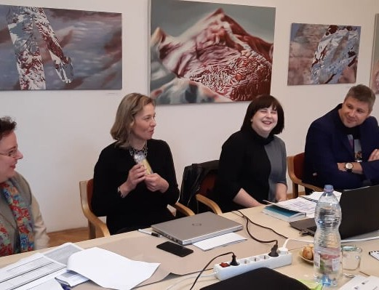

THE MOST IMPORTANT ISSUES OF THE 1ST MEETING

The coordinator presented a short overview about the whole project and about the three INTELLECTUAL OUTPUTS that will be developed within the STEMS project, as well as responsibilities of partners, and major deadlines.

Intelectual outputs:
IO1- How to Motivate and Engage Adult Learners: A Training Programme for Adult Education Staff and Teachers – Dante
A training programme aimed at increasing motivation competences of teachers and staff in adult education.

IO2- How to Motivate and Engage Adult Learners: Open Source Online Platform for Adult Education Staff and Teachers – BDA
An online platform featuring activities and tools in English and partner languages aimed at supporting adult education staff and teachers participating in the training programme.

IO3- Information Guide for Policy Makers – ECA
Guidelines for policy makers responsible for adult education regarding the deployment of professional staff and educators about the importance of their motivation and on how to develop a vision about the importance of adult education in relation to their responsibility for quality assurance and role in the labour market

The piloting of the IO1 will be based on practical and interactive training approach and tools in order to ensure that the target group will have the opportunity to apply marketing tools and methods contextualized in their role. The desired result is to have more competent and professional AE staff that can progress beyond their traditional approach to and culture of education.

